Skyroot Aerospace : A Journey of Entrepreneurship

To me, entrepreneurship is the art of transforming ideas into impactful realities by taking initiative, embracing risks, and constantly innovating. It is not merely about starting a business but about solving problems creatively and persistently, often in the face of uncertainty. Entrepreneurship means having the courage to pursue a vision that others may doubt, while learning and adapting continuously. It embodies resilience, passion, and the willingness to challenge the status quo to bring something new and valuable into the world.

One entrepreneur I deeply admire is Pawan Kumar Chandana, the co-founder and CEO of Skyroot Aerospace, an Indian private space technology company. What attracts me to Pawan and his team is their groundbreaking work in a field traditionally dominated by government agencies and large global corporations. Skyroot’s mission to develop affordable and reliable rocket technology, including the successful launch of India’s first privately developed rocket, marks a significant milestone in India’s space exploration history. Their achievements reflect not only technological innovation but also a bold entrepreneurial spirit that challenges conventional barriers.

The mindset traits that have contributed to Pawan Kumar Chandana’s success resonate strongly with me. First, risk-taking: entering the space industry as a startup requires enormous courage and vision because it is capital intensive and technically demanding. Skyroot’s willingness to innovate with limited resources, invest in research and development, and pursue ambitious goals exemplifies bold risk-taking.

Second, resilience is evident in their journey. The path to building rockets is filled with failures, setbacks, and regulatory challenges. The Skyroot team’s determination to learn from failures and continuously improve their technology highlights their grit and unwavering commitment.

Third, innovation drives their success. Skyroot’s approach to developing advanced rocket engines and launch vehicles using new materials and design concepts sets them apart. Their ability to think creatively, adapt quickly to technical challenges, and leverage cutting-edge technologies demonstrates a culture of innovation.

Finally, adaptability is a key trait. Navigating the complex landscape of space technology, government regulations, and funding constraints requires flexibility and the capacity to pivot strategies when needed. Skyroot’s rapid progress, from founding in 2018 to successful rocket launches within a few years, underscores their adaptability.

Reflecting on these traits, I find that some align well with my own strengths, while others inspire areas for growth. Like Pawan and his team, I am passionate about innovation and eager to explore new ideas. I tend to embrace challenges with curiosity and maintain optimism when facing obstacles. However, I recognize that my risk-taking tendencies are sometimes cautious; I prefer calculated risks but may hesitate in highly uncertain situations. Developing a greater appetite for bold risks would be beneficial for my growth as an entrepreneur.

Additionally, resilience is an area I am actively working to strengthen. While I handle setbacks reasonably well, I sometimes struggle with maintaining long-term persistence when results are slow to materialize. Skyroot’s example reminds me of the importance of enduring commitment and learning from failures without losing momentum.

Adaptability is another trait I aspire to cultivate more consciously. In today’s rapidly changing world, the ability to pivot and embrace change is crucial. Skyroot’s success teaches me the value of remaining flexible and open-minded, even when initial plans need revision.

In conclusion, entrepreneurship is a dynamic journey of creativity, courage, and continuous growth. Pawan Kumar Chandana and Skyroot Aerospace embody the mindset traits of risk-taking, resilience, innovation, and adaptability that are essential for entrepreneurial success. Their story inspires me to nurture these qualities in myself, pushing beyond comfort zones to transform ideas into meaningful impact. As I reflect on my entrepreneurial aspirations, I am motivated to embrace challenges more boldly, persist through adversity, and adapt swiftly to change, following the path charted by visionary entrepreneurs like those at Skyroot.

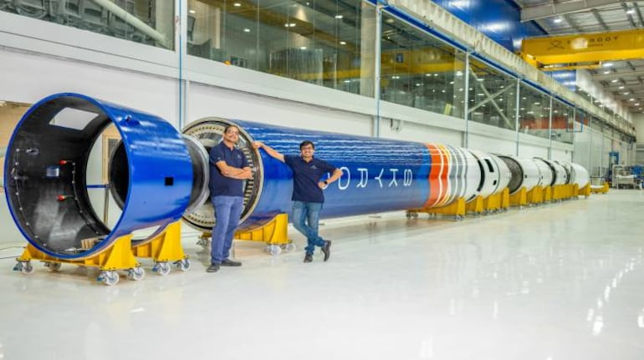

Submitted by –

Name – Ayush Nanasaheb Sonwalkar Roll no. - 03

Name – Shravani Dhananjay Gade Roll no. - 11

Name – Vikrant Vitthal Ghemad Roll no. - 14

Name – Vrushabh Shivaji Gurav Roll no. - 16

Name – Abhiraj Kanifnath Kale Roll no. - 19